

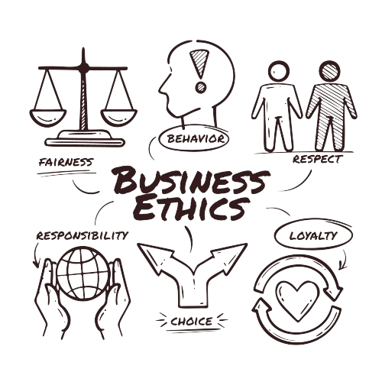
ETHICS POLICY
Effective Date: 01-01-2024

Contents

1. INTRODUCTION 3
2. SCOPE 3
3. POLICY STATEMENT 3
4. KEY FOCUS AREAS 3
5. QUALITATIVE TARGETS 5
6. QUANTITATIVE TARGETS 7
7. CONTINUOUS IMPROVEMENT 9
8. REPORTING 9
9. REVIEW MECHANISM 9

INTRODUCTION
At Graham Packaging Company, we recognize that ethical conduct is fundamental to our success as a leading manufacturer in the plastic bottle industry. We are committed to upholding the highest standards of integrity, transparency, and social responsibility in all aspects of our operations. This Ethics Policy serves as a guiding framework for our employees, outlining the principles and values that define our corporate culture. By adhering to these principles, we aim to foster a workplace environment where honesty, fairness, and respect are upheld, thereby strengthening trust with our stakeholders and contributing positively to society.

SCOPE
This Policy applies exclusively to the operations of Graham Packaging Company, encompassing all employees, contractors, suppliers, and stakeholders directly associated with our facilities.
Sr. No. | Name of Site | Address
1 | Graham Packaging Company | 700 Indian Springs Drive  Suite 100  Lancaster, PA 17601

POLICY STATEMENT
At Graham Packaging Company, we are committed to conducting business ethically and with integrity. We prioritize honesty, fairness, and respect in all our interactions with employees, stakeholders, and the environment. Our Ethics Policy guides our conduct, ensuring transparency, accountability, and adherence to ethical standards in everything we do.

KEY FOCUS AREAS
- Ethical Conduct: Our commitment to ethical conduct is unwavering. We enforce a zero-tolerance approach to corruption, ensuring transparent record-keeping, fair procurement processes, and strict adherence to anti-corruption regulations.
- Conflict of Interest Management: We have established a robust system for managing conflicts of interest. This includes mandatory disclosure of personal interests, strict confidentiality measures to protect sensitive information, and comprehensive ethics training to empower employees to make ethical decisions confidently.
- Fraud Deterrence: We prioritize fraud deterrence through the implementation of controls and procedures aimed at preventing deceptive financial practices. We maintain transparency in financial reporting to foster trust with stakeholders and conduct thorough assessments of vendors and suppliers to mitigate the risk of fraud.
- Anti-Money Laundering Measures: Our commitment to combating money laundering is resolute. We have implemented measures such as regular risk assessments, transaction monitoring systems, and prompt reporting of suspicious activity to the authorities to detect and deter money laundering activities effectively.
- Promoting a Fair Marketplace: We are dedicated to promoting a fair marketplace within the plastic packaging industry. This involves ensuring compliance with antitrust laws, preventing collusion between companies, and implementing policies that support the growth of small and medium enterprises (SMEs).
- Cybersecurity Protocols: Protecting sensitive data is paramount to us. We have established robust cybersecurity protocols, including secure data handling procedures and advanced encryption measures to safeguard customer information and trade secrets across all digital platforms.

QUALITATIVE TARGETS
- Strengthening Ethical Conduct: Conduct quarterly integrity workshops to discuss real-life ethical dilemmas and best practices in ethical decision-making, fostering a culture of integrity throughout the organization.
- Advancing Sustainability Initiatives: For example, invest in research for alternative packaging materials and optimize production processes to minimize waste, promoting a circular economy.
- Enhancing Community Engagement: Collaborate with local schools and nonprofit organizations to educate on recycling and environmental conservation, supporting community development projects. For instance, sponsor recycling awareness campaigns in partnership with local schools.
- Promoting Transparency and Accountability: Maintain open communication channels and regularly publish updates on sustainability efforts to build trust with stakeholders. For example, establish a dedicated section on the company website to provide transparent updates on progress towards environmental goals and initiatives to improve supply chain transparency.

QUANTITATIVE TARGETS
- Ethical Conduct:
- Achieve 100% compliance with anti-corruption regulations by 2025 compared to the baseline year of 2018.
- Maintain transparent record-keeping with zero instances of corruption-related issues.
- Conduct annual ethical conduct assessments, aiming for a score of 95% or above.

- Conflict of Interest Management:
- Ensure 100% of employees complete comprehensive ethics training by 2025.

- Fraud Deterrence:
- Reduce instances of fraudulent financial practices by 50% by 2025 compared to 2018 levels.
- Conduct quarterly assessments of vendors and suppliers, aiming for a completely eliminate fraud risk associated with suppliers and vendors.

- Anti-Money Laundering Measures:
- Achieve a 90% effectiveness rate in detecting and reporting suspicious activities by 2025 compared to the baseline year of 2018.
- Conduct bi-annual risk assessments, with a target of reducing overall money laundering risk by 30% compared to 2018.

- Promoting a Fair Marketplace:
- Ensure 100% compliance with antitrust laws and regulations by 2025 compared to the baseline year of 2018.
- Implement policies that result in a 20% increase in SME (Small and Medium Enterprises) participation within the plastic packaging industry by 2025 compared to the baseline year of 2018.

- Cybersecurity Protocols:
- Enhance cybersecurity measures to achieve a 99% success rate in preventing data breaches or cyberattacks by 2025, compared to the baseline year of 2018.

CONTINUOUS IMPROVEMENT
- Continuous improvement is intrinsic to Graham Packaging's Ethics Policy.
- We prioritize systematic evaluation and feedback mechanisms to foster transparency, accountability, and integrity. Employees are encouraged to voice concerns openly, creating a culture of trust and vigilance against unethical practices.
- Proactive engagement with stakeholders helps us address emerging ethical challenges and regulatory changes effectively.

REPORTING
- To promote sustainability within the plastic packaging manufacturing sector, Graham Packaging has established a comprehensive reporting mechanism within our Ethics Policy.
- This mechanism includes regular policy reviews, the formation of a review committee, clear incident reporting procedures, structured investigation protocols, thorough documentation and record-keeping, ongoing training and awareness programs, continuous improvement initiatives, and transparent communication practices.

REVIEW MECHANISM
- Annually, Graham Packaging will conduct a comprehensive review of its Ethics Policy to evaluate adherence to ethical standards, identify areas for improvement, and ensure alignment with industry best practices.
- Continuous improvement and accountability remain paramount in upholding our ethical commitments. Our commitment to ethical excellence drives us to continually raise the bar and ensure that our actions reflect our values.

